TRAVEL AND TOURISM MANAGEMENT SYSTEM

* **Pranita Maindargikar(39)**
* **Kalash Chandak(11)**
* **Haseeb Sediqi(63)**

PROGRESS REPORT

1. **SCOPE AND PURPOSE**

Everyone has a dream of exploring this beautiful world. Some do it to seek pleasure in form of thrill, adventure, excitement, enjoyment that takes them away from their daily tedious routine while others do it as a hobby or some business purpose. Also promoting tourism is one of the best ways to increase the export of a country and it also increases the **revenue**of a country. This has boomed the travel and tourism industries across the globe. We find numerous agencies providing all kinds of services to suffice their customers with the best experience in travelling and tourism. Therefore there is a need to check whether the customers are satisfied with the company’s efforts.

Tourism business involves tedious manual tasks like updating tour information, booking, documentation and payment, etc. Therefore main reason of computerization of a system is that it speeds up the tasks saving both time and money. Computer tourism system helps to present data in an effective manner. It also makes inputting information simple for searching and viewing. Moreover, computerizing a system helps to keep business organized. Storing information is vital to a business. In Computerized System data can be stored quickly and indefinitely. Securing business’ valuable data is a huge priority. The use of computerized software can be helpful here. In addition to this, computer software can automate above processes. Last but not the least it also helps to keep data accurate and up-to-date.

1. **PROGRESS**

The project is comprised of various modules and functionality. Out of which the basics have been done including the main home page, login page, tours, about us and contact us. The page is also equipped with database for storing login information of the users. The following Gantt chart explains the time taken for completion of the modules:

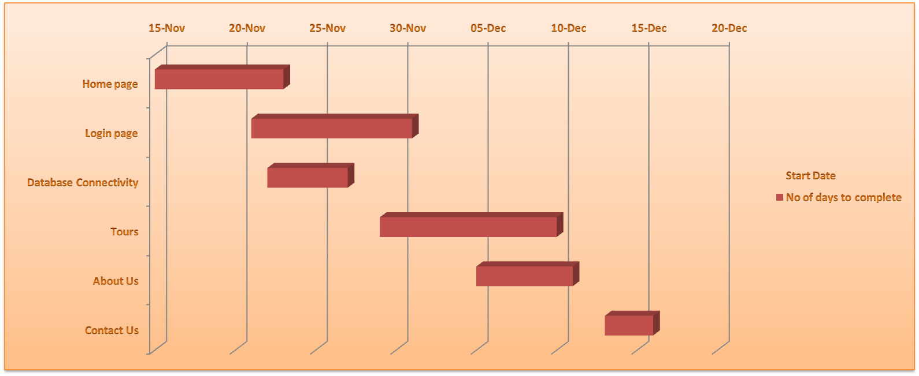

1. **WORK REMAINING**

The website needs a few more features and functionalities added to it in order to be complete. These include the main Admin dashboard along with his database connectivity, tour database. Finally it should also hold the option of payment for booking tours with all kinds of payment options.

1. **ADDITIONAL WORK**
2. **EXPECTED RESULTS**

A fully functioning website ready to use by any travel company to further their business.